
34, VISHALA ESTATE, S.P.RING ROAD,OPP.ODHAV TO NIKOL ROAD, NIKOL, Ahmedabad, Gujarat, 382350
GST NO:-:24ARDPD2565K1ZX

info@torqpackagingsolution.com
www.torqpackagingsolution.com

To.

Sub: - Automatic oil packing machine
Dear Sir,
Many thanks for your valuable inquiry of above subject. TORQ PACKAGING Solutions Is engage in making preliminary Bottle Packaging machines like bottle filling , capping , labeling, Automation, etc… in Ahmedabad, We are having dedicated team for manufacturing, customized machine development, Sales, servicing and back office.

Thanks & Regards
Ronak Dave
+91 80000 32128

Automatic Four Head Filling machine
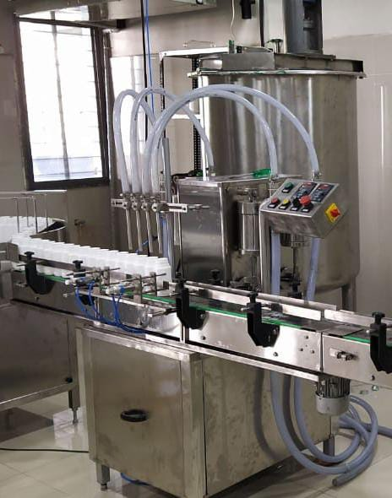
Description
Automatic Volumetric Liquid Bottle Filling Machine works on volumetric principle with diving nozzles. The unit is made compact, versatile and enclosed in stainless steel elegantly matt finish body, consists of S.S. Slat Conveyor,
Reciprocating Nozzle with self-centering devices & SS Syringe. No container No filling system arrangement is standard features of the machine.
The main drive of the machine and conveyor drive consist of A/c Motor with synchronized variable A/c Frequency Drive.
Operation
Containers moving on SS Slat conveyor, feed below the filling nozzles through a settable twin pneumatically operated stopper system. The twin pneumatically operated stopper system and reciprocating nozzles can precisely match for centering of container below nozzles, to avoid spillage of liquid on container.
To minimize foaming adjustable nozzle will reciprocate according to filling dose, nozzle will go upwards slowly from bottom level of bottle towards neck during filling. The dosing block with a hexagonal bolt fitted below syringes. This means fill size can be easily set.
Technical Specifications
Filling Range*** |  |  | 5 ml to 1000 ml
Output/Hour* |  |  | 1200 to 2400*
Direction of Movement |  |  | Left to Right
Number Of Head / Syringe |  |  | 4 Nos.
Power Consumption | Main Machine |  | 1 HP / 415 V / 50 HZ
 | Conveyor |  | 0.5 HP / 415 V / 50 HZ
Height of Conveyor |  |  | 850 mm to 900 mm Adjustable
Machine Dimensions** |  |  | 1800 mm (L) x 950 mm (W) x 1800 (H) Approx.
Case Dimensions |  |  | 1950 mm (L) x 1100 mm (W) x 2000 (H) Approx.
Net Weight |  |  | 450 Kegs. Approx.
Input Specification
Container Neck Diameter** |  |  | Minimum 22 mm***
Container Size** | Round Shape |  | Ø 28 mm to Ø 100 mm
Respectively height 58 mm to 240 mm
(Height option for other bottle height available)
 | Flat / Square |  | 15mm to 100 mm (Length)  Respectively 10mm to 50 mm (Width)  Respectively height 58 mm x 240 mm  (Height option for other bottle height available)
* Depends on Container size, fill size, Neck diameter of container, and nature of liquid etc.
** We can supply as per customer requirements.
*** With help of change parts.
Salient Features
- ±1 % filling accuracy on single dose.
- No Bottle No Filling System.
- Rigid vibration free construction for trouble free performance
- S.S. Elegantly matt finished body.
- Minimum charge overtime, from one size to another container or fill size.
- Self-lubricating UHMW-PE guide profile for S.S. slat chain provides low friction wear surface, smooth and noiseless conveying.
- Bottle Stopping arrangement through Pneumatic system.
- Synchronized two nos. A/c drives for main motor & conveyor belt.
- Safety guard for conveyor gearbox, motor and pneumatic cylinders.
- Inbuilt protection against over current, voltage fluctuation, short circuit in A/c frequency drive.
- Total GMP model.
Utility Requirement
Electrical supply |  | 1 Phase + Neutral + Earthling
Electrical load |  | 1 KW
Air Pressure |  | 6 bar pressure 0.5 CFM

Automatic Single Head CTC/Screw Capping Machine

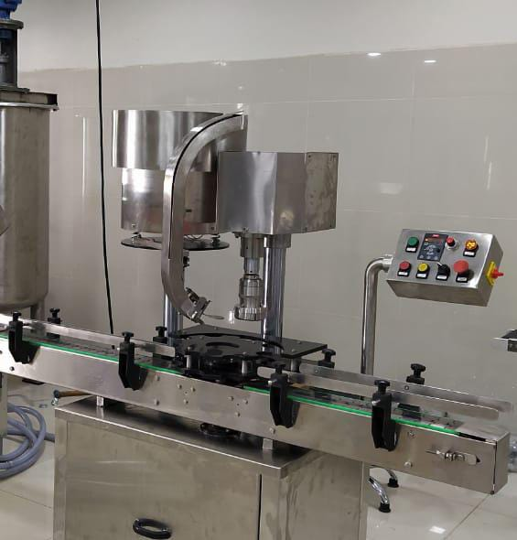
Description
Automatic Screw cap sealing machine is versatile, self-supported on stainless steel leg with height adjustable adjustment system. The machine is precision built on sturdy welded steel frame completely enclose in stainless steel sheet and doors are provided to facilitate the servicing of machine

Operation
The feed container moving on conveyor belt are fed into star wheel, bringing the container below the sealing head in the subsequent indexing part, meanwhile the bottle pick up a cap from the delivery chute of cap feeding bowl, where the body and the neck of the container are positioned below the rotating head, where the sealing head is performing perfect operation of capping.
Technical Specifications
Output/Hour* |  |  | 1000 to3000 bottles
Direction of Movement |  |  | Left to Right
No. of Sealing Head |  |  | 1 Nos.
Power Consumption | Main Motor |  | 1 HP / 415 Volts / 50 Hz.
 | Cap Feeding Bowl |  | 300 watt, Magnetic coil
Height of Conveyor |  |  | 860 mm to 910 mm
Machine Dimensions** |  |  | 2000 L x 1100 W X 1700 H
Case Dimensions |  |  | 2150 mm (L) x 1150 mm (W) x 1800 (H) Approx.
Net Weight |  |  | 350 Kgs. Approx.
Gross Weight |  |  | 500 kgs.
Change parts required |  |  | - Container: Star Wheel, Back Guide, Feed Worm  - Cap Die, Delivery Chute, Bowl
Input Specification
Screw Cap | Diameter** |  | 19 mm to 38 mm***
Specification | Height** |  | 15 to 18.3 mm
Container Size** | Round Shape |  | Ø 28 mm to Ø 100 mm  Respectively height 58 mm to 240 mm  (Height option for other bottle height available)
 | Flat / Square |  | 15mm to 100 mm (Length)  Respectively 10mm to 50 mm (Width)  Respectively height 58 mm x 240 mm  (Height option for other bottle height available)
* Depends on bottle size, cap size and type of cap.
** We can supply as per customer requirements.
*** With help of change parts.
Salient Features
- No container No cap arrangement.
- SS elegantly matt finished body.
- Single motor synchronizes conveyor, star wheel.
- Adjustable height of conveyor belt, to align with other machine of the line.
- Sealing pressure can be varied to suit different gauges and size of caps.
- Low noise level, low power consumptions.
- Self-lubricating UHMW-PE guide profile for low friction wears surface, smooth and noiseless conveying.
- SS cladding or hard chrome plating of all exposed parts to ensure long life and resistance against corrosion.
- Synchronized A/C drives to synchronize, Conveyor, Star wheel and Platform turret & capping bowl.
- Adjustable bottle height gauge for easy and quick setting.
Utility Requirement
Electrical supply |  | 1 Phase + Neutral + Ear thing
Electrical load |  | 0.75 KW

Automatic sticker labeling machine for round bottle
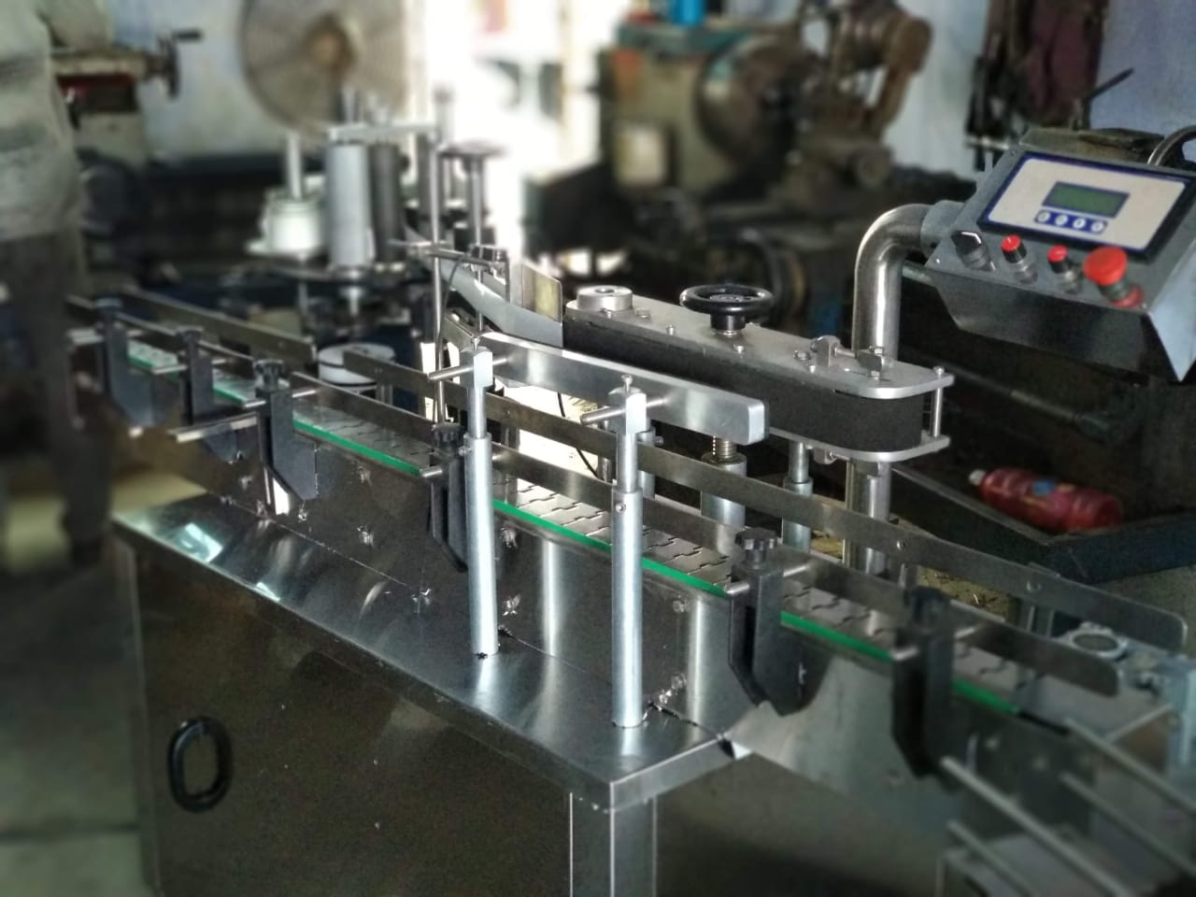
Description
The Automatic Vertical Sticker Labeling Machine is one of the most users friendly. The machine is used for full/partial labeling on different size of flat or rectangular containers. The automatic model is equipped with roller spacing device resulting in a simple operation with “No change parts required”.
Operation
The filled and sealed bottle is conveyed from the Conveyor and on the same conveyor one bottle separator attachment is provide to separate the bottle from continuous movement. A sensor provided to sense the product after sensing the sensor give command to operate steeper or servo motor to release label when one label is stick the gap sensor give command to stop the servo or stepper during releasing of label provision of brush to press the label & remove the air between label & bottle after completion of the cycle one operation of labeling is finish & conveyor bring the bottle for next operation..
Technical Specifications
Output/Hour* |  |  |  | 4000 to 6000
Direction of Movement |  |  |  | Left to Right
Controlling |  |  |  | Microprocessor base control
Power Consumption | Conveyor motor |  |  | 0.5 HP / 415 V / 50 HZ
 | Pressing device motor |  |  | 0.25 HP / 415 V / 50 HZ
 | Stepper motor |  |  | 60 kg / cm2
Height of Conveyor |  |  |  | 850 mm to 900 mm Adjustable
Machine Dimensions** |  |  |  | 1828 mm (L) x 610 mm (W) x 1200 (H) Approx.
Case Dimensions |  |  |  | 2000 mm (L) x 700 mm (W) x 1325 (H) Approx.
Net Weight |  |  |  | 350 Kgs. Approx.
Gross Weight |  |  |  | 600 kgs Approx.
Input Specification
Label Specifications |  | Length** |  | 240mm Max
 |  | Roll Diameter |  | Max 300 mm & ID 75 mm
 |  | Space between two label |  | Min. 3 mm anti clock wise
* Depends on Container size, fill size, Neck diameter of container, and nature of liquid etc.
** We can supply as per customer requirements.
Salient Features
- High Production Speeds.
- SS steel structure cladded with stainless steel 304 sheet to meet GMP norms.
- Microprocessor Based operation
- Accurate label placement.
- No change parts requirements.
- Very less down time for change over.
Utility Requirement
Electrical supply |  |  | 1 Phase + Neutral + Earthling
Electrical load |  |  | 1 KW

Price Breakup
S.N. | PARTICULERS | CAPACITY | QTY | AMOUNT RS.
1 | Automatic 4 head filling machine (up to 1 ltr) |  | 1 | 2,80,000/-
2 | Automatic 1 head capping machine |  | 1 | 2,20,000/-
3 | Automatic round bottle labeling machine |  | 1 | 2,40,000/-
 | BANK DETAIL :  Account name :- TORQ PACKAGING SOLUTION  Account number :- 8000032128  Bank name :- KOTAK MAHINDRA BANK LTD  Branch :- KATHWADA  IFSC :- KKBK0002606  COMPANY GSTIN : 24ARDPD2565K1ZX | TOTAL |  | 7,40,000/-
 |  | CGST @ 9%
 |  | SGST @ 9%
 |  | IGST @ 18% |  | 1,33,200/-
TOTAL AMOUNT |  |  |  | 8,73,200/-
TERMS & CONDITIONS |  | For, TORQ Packaging Solution
- 60 % Advance on Signing up of Contract
- 40% On Completion of Machinery Manufacturing Before Dispatch / During Inspection of machinery
- Order Once Placed Cannot be Cancelled
- No Refund will be entertained

Required change parts for machine
Vibrator bowl (not required if cap size same) | 1 | 35,000/-
Capping suit (not required if cap size same) | 1 | 12,000/-
Capping head (not required if cap size same) | 1 | 10,000/-
Star wheel (require for every size of bottles) | 1 | 13,000/-

- Terms & Conditions

1 | PRICE | The prices mentioned are ex our Ahmadabad works
2 | TAXES & DUTIES | 18% extra
3 | TERMS OF PAYMENT | We agreed to have 60% advance and 40 % before Dispatch.
4 | DELIVERY  PERIOD | Within 3-4 Weeks from the date of receipt of technically & commercially clear order along with advance payment or receipt of approval for input dimensions, whichever is later
5 | INSURANCE | Transit Insurance against Theft, Pilferage, Breakage, Etc. will be arranged at extra cost at your explicit instruction, otherwise it will be assumed that goods are to be sent at your risk. Cost of such insurance will be as actual to be borne by the consignee.
6 | TRANSPORT | Transportation of the machine from our factory has to be arranged by you. We will arrange for loading of the equipment at our factory. However unloading at site has to be arranged by you. Our responsibility ceases once the goods leave our factory and are handed over to carrier. We do not undertake any liability for damage/ loss in transit whatsoever, whether the goods are insured or not. In case of any damage / accident during transit, the client has to directly deal with the insurance company without holding any payments, irrespective of the insurance arranged by Consigner or Consignee.
7 | INSPECTION | We offer inspection of the machine at our factory, by your technically competent representative, prior to dispatch. This person should be present on our factory during packing and loading of the machine. In case you are not deputing anyone for pre dispatch inspection, then we will not entertain any dispute arising out of short supply, quality, workmanship, functionality, operating parameter, etc. once the machine is dispatched.
8 | FACTORY  TRAINING | We will impart training to your operating staff in our factory before the machine is dispatched, at no additional cost. However, his lodging-boarding and local traveling expenses will have to be borne by you. This person should be technically competent to uncrate and assemble the machine at site before the arrival of our commissioning engineers. He must ensure that ground work necessary at site is competed in all respects before machine. Commissioning, He must be competent enough to be able to run the machine and carry out routine maintenance, once the machine is handed over after commissioning
9 | INSTALLATION | The machine has to be uncarted and placed in working position by you at site. You have to carry out all the external powers and air compressor at site. The machine must be available in the fully assembled condition when our commissioning engineer arrives at site.
10 | COMMISSIONING | For supervising and commissioning of the machine we will depute one of our engineers on chargeable bases. Customer will have to send a prior intimation of readiness of electrical and utility connections along with required materials.  Rs. 2,000/- per man day will be charged. Customer will reimburse to and for 1st class fare from  Ahmedabad to the destination, lodging and boarding expenses and other local expenses for the period of commissioning.
11 | SPECIFICATION | In line with our policy of continual improvements, we reserve The right to modify the design and change the specifications and make of any material, if in our opinion such modification leads to an improvement in the performance of the machine. Therefore specification, illustrations, dimensions, offers, drawings or photographs are not binding in detail.
12 | WARRANTY | Our goods carry a warranty of one-year trouble free operation from the date of dispatch. The warranty is only against manufacturing defect. It does not cover any electrical, electronic or bought out components.  Components getting normal wear and tear would be replaced at your cost.
13 | NOTE | Customer have to provide samples of bottles, caps, labels etc. along with the purchase order otherwise machine will be made as per our standard specifications, wherein we will take trial with water, caps, bottle, label etc available with us, which will be acceptable to you.
14 | CANCELLATON  OF ORDER | Order once placed, cannot be cancelled under any circumstances. In case of orders being cancelled, then the entire amount of advance payment will stand forfeited.
15 | OFFER VALIDITY | This offer remains valid for the period of 30 days. Any extension thereafter will be subject to our written confirmation only.
16 | JURISDICTION | No legal proceedings shall be taken to enforce claims and no suit arising out of any contracts shall be instituted except in a court of competent jurisdiction located within Ahmedabad, Gujarat.

